Appendix 4 The 5th ASEF
Hotel Information

1. Novotel Ambassador Busan
- Location : 1405-16, Jung-Dong, Haeudae-Gu, Busan, Korea
- Tel : +82-51-743-1234
http://www.novotelbusan.com/eng/index.php

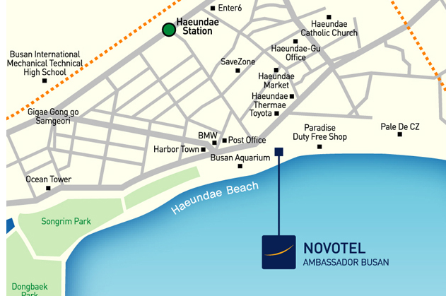

Room Type | Special Rate | Type | - Korean Won  - service charge included  - Breakfast will be added per person per request.  (￦21,780)  - Check in time 2PM  Check out time 12PM
Deluxe Half Ocean | 290,400 | Double / Twin

If you wish to take advantage of this special rate, please return below hotel reservation form by November 15th, 2011 to bmjeon@koshipa.or.kr
(At the same period of 5th ASEF, OECD Meeting is scheduled to be held at Heaundea, Busan. Therefore, the rest of room is not enough, please hurry to make a reservation.)

2. Toyoko Inn Busan Haeunde Hotel
- Location : 1130-1 Jung-Dong Haeundae-gu, Busan, Korea
- Tel : +82-51-256-1045 Fax:+82-51-256-1046
http://www.toyoko-inn.com/e_hotel/00242/index.html

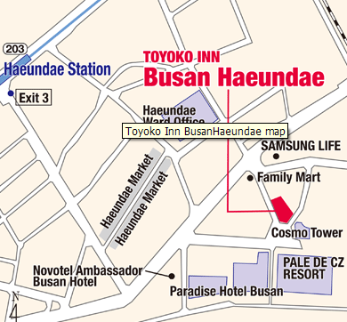

Room Type | Rate | Notice | - Korean Won  - service charge included  - Breakfast included  - Cancellation charge applies from 16:00 on the date of arrival , if no prior notice  - Check-in Time 4PM  Check-out Time 10AM
Double Room B | 77,000 | Fri, Sat, and day before holidays  88,000
Twin Room | 77,000 | Fri, Sat, and day before holidays  88,000

If you wish to take advantage of this special rate, please return below hotel reservation form by November 15th, 2011 to bmjeon@koshipa.or.kr
(At the same period of 5th ASEF, OECD Meeting is scheduled to be held at Heaundea, Busan. Therefore, the rest of room is not enough, please hurry to make a reservation.)

Hotel Reservation Form

Family Name (Mr./Ms./Dr./Prof.) |  | First Name
Position
Organization
Address |  | Zip code
City |  | Country
Tel. |  | Fax
E-mail
Date of Arrival |  | Date of Departure
Accompanied by
Hotel selection |  |  | Room Type
1. Novotel □ 2. Toyoko-Inn □
All reservations must be guaranteed by the individual delegates for late arrival by either credit card or one night room rate as a deposit.
Card Type  (Visa/Master/Amex etc.) |  | Card Holder's Name
Card No.
Exp. Date | (mm/yy)
Remarks

please return hotel reservation form by November 15th, 2011 to bmjeon@koshipa.or.kr

